ANNEX I
UNESCO-Japan Prize on
Education for Sustainable Development (ESD)
Explanatory note
2016 Call for Nominations
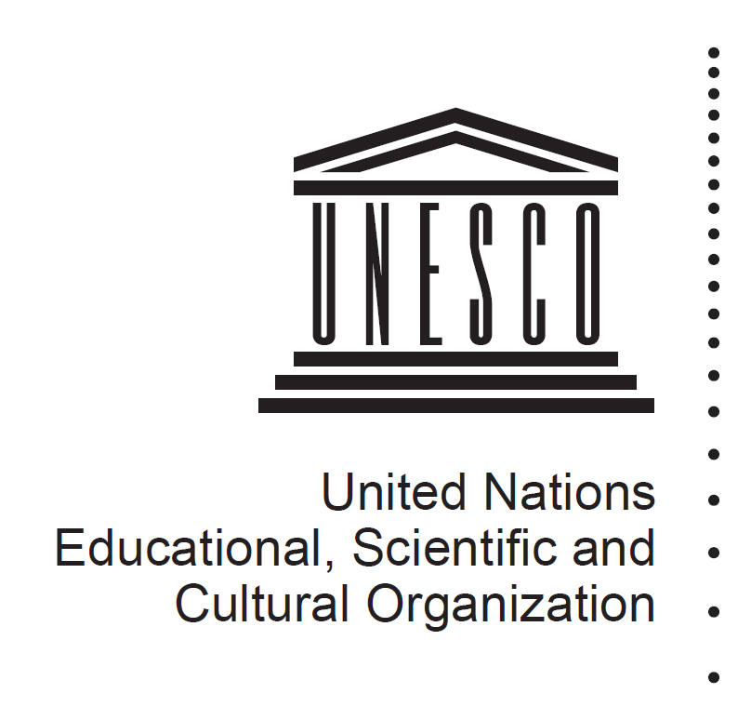

Background
Within the framework of the Global Action Programme (GAP) on ESD, the UNESCO-Japan Prize on Education for Sustainable Development (ESD) honours individuals, institutions, organizations or other entities for outstanding projects or programmes in the field of ESD. The Prize was established by the Executive Board of UNESCO at its 195th session, and officially announced at the UNESCO World Conference on ESD (10-12 November, 2014, Aichi-Nagoya, Japan).
It consists of three annual awards of US $50,000 for each recipient, and was awarded for the first time in November 2015.

Nominations
Nominations can be made by Governments of UNESCO Member States via their Permanent Delegation to UNESCO, and Non-Governmental Organizations (NGOs) in official partnership with UNESCO. Nominations must focus on a specific ESD project or programme of the nominee. Each Permanent Delegation or NGO can make up to three nominations for any edition of the Prize.
Self-nominations are not accepted.

Selection Criteria
The three Prize winners will be selected by the Director-General of UNESCO on the basis of recommendations made by the independent International Jury of the UNESCO-Japan Prize, consisting of five experts from all geographical regions. The project/programme of the nominee will be assessed by the Jury on the basis of the following criteria:
a. Transformation: The project/programme practices ESD as transformative education in support of sustainable development, leading to individual and social change.
ESD is transformative education in that it empowers learners to transform themselves and the society they live in. The project/programme of the nominee should therefore enable learners to bring about changes for a more just, peaceful and sustainable world. This can mean, for example, taking action against climate change, changing one’s consumption patterns, developing social entrepreneurship and sustainable livelihoods, or supporting those struggling against poverty.
b. Integration: The project/programme addresses the three dimensions of sustainable development (society, economy, environment) in an integrated way.
Sustainable development calls for the integration of the social, economic and environmental dimensions of development. The project/programme of the nominee should be in line with this definition of sustainable development. It should address the three dimensions (society, economy, environment), and help learners understand the interdependence between them and act accordingly.
c. Innovation: The project/programme demonstrates an innovative approach to ESD.
Sustainable development requires going beyond ‘business as usual’ and ‘out-of-the-box’ thinking. The project/programme of the nominee should demonstrate an innovative and inspirational approach to ESD, be it in the themes it covers, the methodology it employs, or the way the learning environment is designed. Reaching out to sectors beyond education and working with new partners can also be a sign of innovation.

In addition to these three criteria, the project/programme should:
- have already been running for at least two years
- show presence of evidence of results and a high impact relative to the invested resources
- be replicable and scalable
- contribute to one or more of the five Priority Action Areas of the GAP (advancing policy; transforming learning and training environments; building capacities of educators and trainers; empowering and mobilizing youth; accelerating sustainable solutions at local level).

UNESCO-Japan Prize on Education for Sustainable Development
2016 Call for Nominations
Nomination Form

Please present the project/programme of the nominee in a clear and structured way.
Kindly make sure that all boxes of the form are completed according to the
instructions given.

1. SUBMISSION
Nomination submitted by:
Member State
Country:
Non-Governmental Organization (NGO) in official partnership with UNESCO
Name:
Name of submitting person:
Function:
E-mail:
Telephone:
Supporting statement by the nominator
[Please complete the following sentence in a maximum of 40 words:]
The nominee deserves to receive the UNESCO-Japan Prize on ESD because…

2. NOMINEE
Specify if the nominee is an: | Individual
or an: | Organization  Type of Organization:  Governmental body  International Organization  Civil society organization  Private sector/business  Media  Academia/research institution  Education institution  Other: [Please specify]
Name of Organization/
Individual
Name of Contact Person
Function of Contact Person  or Individual | [e.g. Director, Project Manager]
Email of Contact Person
or Individual
Mobile number | [with country code]
Telephone | [with country code]
Postal address of Nominee
Nominee’s country and region
Description of the nominated Organization/ Individual | [Please provide a summary description in a maximum of 150 words.]
Website
3. PROJECT/PROGRAMME
a. Project/programme title
b. Project website
c. Abstract
[Kindly explain the objective of the project/programme and its methodology in a maximum of 150 words. Please include all important information in a structured way.]

d. Contribution to the Global Action Programme on ESD (GAP)
Tick the Priority Action Area of the GAP to which the project/programme mainly contributes:
Advancing policy
Transforming learning and training environments (whole-institution approaches)
Building capacities of educators and trainers
Empowering and mobilizing youth
Accelerating sustainable solutions at local level
e. Main target group(s)
Governments (National/Sub-national/Local)
Intergovernmental organizations
Civil society organizations
Business
Media
Academia/research institutions
Education institutions
Educators
Youth
Other: [Please specify]
f. Geographical coverage
International
Regional
National
Local
Countries:
g. Number of beneficiaries to date
[Please indicate the number of current and previous beneficiaries]

h. Duration
[Indicate the start and expected end date. Please note that only projects having been running for at least two years will be considered.]

i. Funding
[Please explain the current and planned funding source(s) of the project/programme.]

j. Resources
Annual project cost: [Please specify the amount for 2015 in USD]
Number of staff involved in the project per year: [Please specify the number of staff in 2015]

k. Future strategy
[Clearly describe the future strategy of the project/programme in a maximum of 150 words. Indicate information such as follow-up plan, scaling-up strategy, target groups, duration and budget.]

l. Achievements and impact
[Please provide evidence of achievements and the impact that the project has had so far, using concrete information such as feedback or quotations by participants, material or publications produced, number and type of individuals or organizations trained, press coverage, previous awards received, number of views of the project website, in a maximum of 150 words.]

m. Transformation:
[Please describe how the project/programme practices ESD as transformative education in support of sustainable development, leading to individual and social change, in a maximum of 200 words.]

n. Integration:
[Please describe how the project/programme addresses the three dimensions of sustainable development (society, economy, environment) in an integrated way, in a maximum of 200 words.]

o. Innovation:
[Please specify how the project/programme demonstrates an innovative approach to ESD, in a maximum of 200 words.]

4. Supporting material
a. Web links (websites, publications, videos, photo galleries)
[Please provide up to 10 relevant web links with a short description.]

b. Other supporting documents
[To upload any supporting documents not available online, please use the “Attach File” function in the “EDIT” tab in the top left corner.]

